**Azure Container Service**

Azure Container Service makes it simpler for you to create, configure, and manage a cluster of virtual machines that are preconfigured to run containerized applications. It uses an optimized configuration of popular open-source scheduling and orchestration tools. This enables you to use your existing skills, or draw upon a large and growing body of community expertise, to deploy and manage container-based applications on Microsoft Azure.

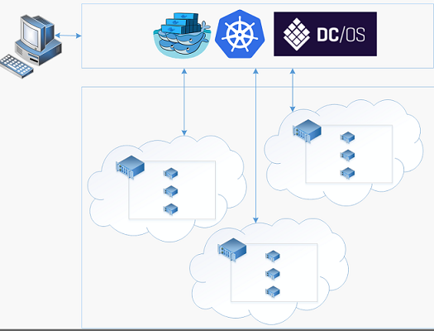

Azure Container Service leverages the Docker container format to ensure that your application containers are fully portable. It also supports your choice of Marathon and DC/OS, Docker Swarm, or Kubernetes so that you can scale these applications to thousands of containers, or even tens of thousands.

By using Azure Container Service, you can take advantage of the enterprise-grade features of Azure, while still maintaining application portability--including portability at the orchestration layers.

**Orchestration Tools**

we expose the standard API endpoints for your chosen orchestrator (DC/OS, Docker Swarm, or Kubernetes). By using these endpoints, you can leverage any software that is capable of talking to those endpoints. For example, in the case of the Docker Swarm endpoint, you might choose to use the Docker command-line interface (CLI). For DC/OS, you might choose the DCOS CLI. For Kubernetes, you might choose kubectl.

**Using Docker Swarm**

Docker Swarm provides native clustering for Docker. Because Docker Swarm serves the standard Docker API, any tool that already communicates with a Docker daemon can use Swarm to transparently scale to multiple hosts on Azure Container Service.

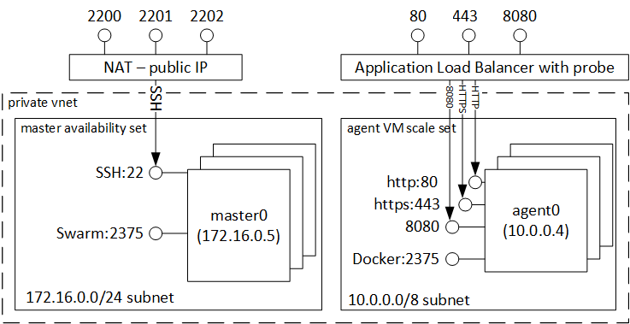

Note

The Docker Swarm orchestrator in Azure Container Service uses legacy standalone Swarm. Currently, the integrated [Swarm mode](https://docs.docker.com/engine/swarm/) (in Docker 1.12 and higher) is not a supported orchestrator in Azure Container Service. If you want to deploy a Swarm mode cluster in Azure, use the open-source [ACS Engine](https://github.com/Azure/acs-engine/blob/master/docs/swarmmode.md), a community-contributed [quickstart template](https://azure.microsoft.com/resources/templates/101-acsengine-swarmmode/), or a Docker solution in the [Azure Marketplace](https://azuremarketplace.microsoft.com/).

Supported tools for managing containers on a Swarm cluster include, but are not limited to, the following:

* Dokku
* Docker CLI and Docker Compose
* Krane
* Jenkins

**Using Kubernetes**

Kubernetes is a popular open-source, production-grade container orchestrator tool. Kubernetes automates deployment, scaling, and management of containerized applications. Because it is an open-source solution and is driven by the open-source community, it runs seamlessly on Azure Container Service and can be used to deploy containers at scale on Azure Container Service.

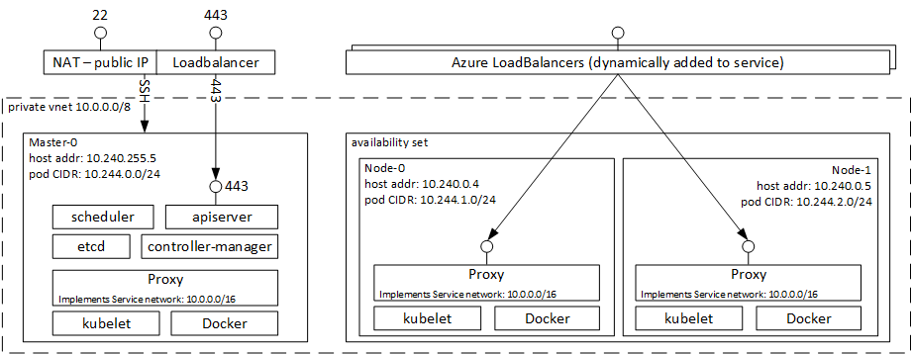

It has a rich set of features including:

* Horizontal scaling
* Service discovery and load balancing
* Secrets and configuration management
* API-based automated rollouts and rollbacks
* Self-healing